What is the TOS?
The Theosophical Order of Service (TOS) is a world-wide organisation based on recognition of the unity of all life and aimed at reducing suffering and injustice at all levels – human, animal and environmental.
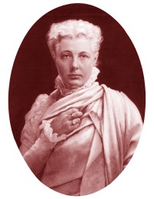
The TOS was founded in 1908 by Dr Annie Besant, then International President of the Theosophical Society, to provide an opportunity for participation in activities which promote the first Object of the Theosophical Society: ‘to form a nucleus of the Universal Brotherhood of Humanity, without distinction of race, creed, sex, caste or colour’.
The TOS is a separate organisation from the Theosophical Society but is closely linked with it. Study, meditation and service are the three components of theosophical living. The TOS provides a framework in which theosophical principles can be applied in daily life and to issues of contemporary concern.
The distinctive, two-fold purpose of the TOS is selfless service to the needy and suffering and the inner transformation of the server that this requires. Dr Besant summarised the mission of the TOS in its motto:
A union of those who love in the service of all that suffers.
Today there are many active TOS groups around the world, united in their ideal of selfless service.
The TOS is a non-profit organisation whose members are its greatest resource. They work as unpaid volunteers and donations are used for service projects, not for administration.

What does the TOS do?
TOS groups around the world work in a variety of areas including peace, social welfare, education, healing, animal welfare and the environment.
Members may work on individually selected activities or on group projects, sometimes in partnership with other groups.
While most service work is carried out in local communities, members also contribute to regional or national projects. Some TOS groups also raise funds for major, long-term projects organised by TOS groups in other countries.
The aim of TOS members is altruistic service that springs from their inner spiritual work. It is service with no intention of benefit to themselves or to their own agenda.
There can be no greater purpose in life than to serve — service to the One in many forms.
It must not be so-called, limited service, but real service, which is direct and sincere, in which the consciousness of self is forgotten.
N. Sri Ram

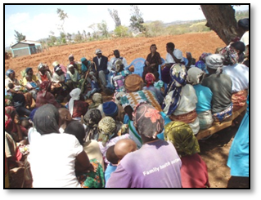

A village meeting organised by the TOS in Kenya to manage their new water bore

Examples of TOS projects
TOS members are involved in a wide range of service activities to help people living in poverty improve their lives, to help animals, and to promote a wider world view. These projects include:
- providing vocational training programs for rural women
- funding and supporting childcare centres and orphanages
- establishing and funding schools
- providing educational scholarships
- providing medical and dental health-care
- providing mobility aids, spectacles and hearing aids
- working with a village to put in a water bore and establish orchards and crops
- holding meditations for World Peace and healing
- providing blankets, clothing and food in emergencies
- promoting non-violence
- funding and supporting veterinary care and animal shelters
- conducting talks and seminars to raise awareness of environmental, health, animal welfare and social issues
- campaigning on contemporary issues.


Students of the Golden Link College run by the TOS in the Philippines

Membership
The TOS welcomes all who are in sympathy with its aims and wish to put into practice the concept of the Universal Oneness of all life.
You do not need to be a member of the Theosophical Society to join the TOS or participate in its work. We welcome any contribution to our work – time, energy, money and expertise.
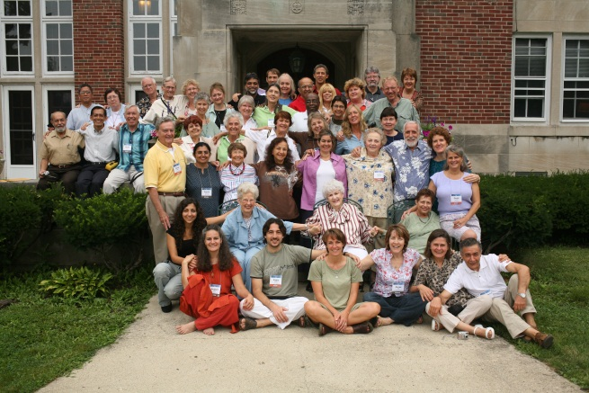
Participants at an International TOS gathering
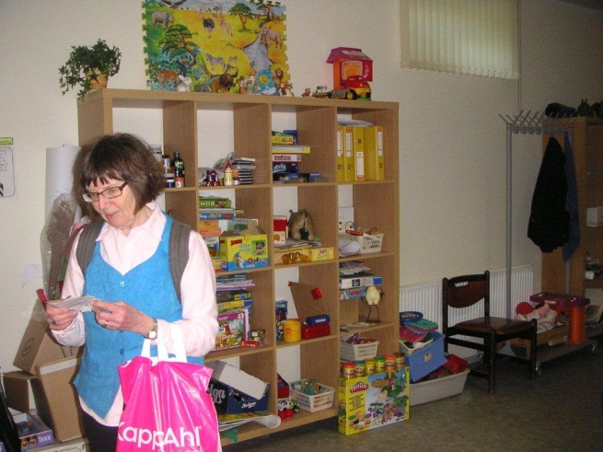

The toy-room in a childcare centre in Latvia supported by the Swedish TOS

Please join us in putting theosophy into action

You are invited to contact your local TOS group and work with us for peace, planet sustainability, compassion and harmony.

For contact details in your country, please go to the list on the home page of the international website:
http://international.theoservice.org

To learn more about us and what we do, visit our international website at: http://international.theoservice.org/

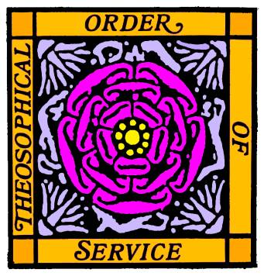

The Theosophical Order of Service

Do you care about:
- peace
- justice
- the welfare of people and animals
- the environment
- healing?

The TOS invites you to join its members who are working to make a difference in these areas.

