 | REGISTRATION FORM  FOR INTERNATIONAL DELEGATES  2013 TSA Summer National Convention  & TOS International Conference  Fill out and return via e-mail to:  Registrar, Theosophical Society in America: registrar@theosophical.org | 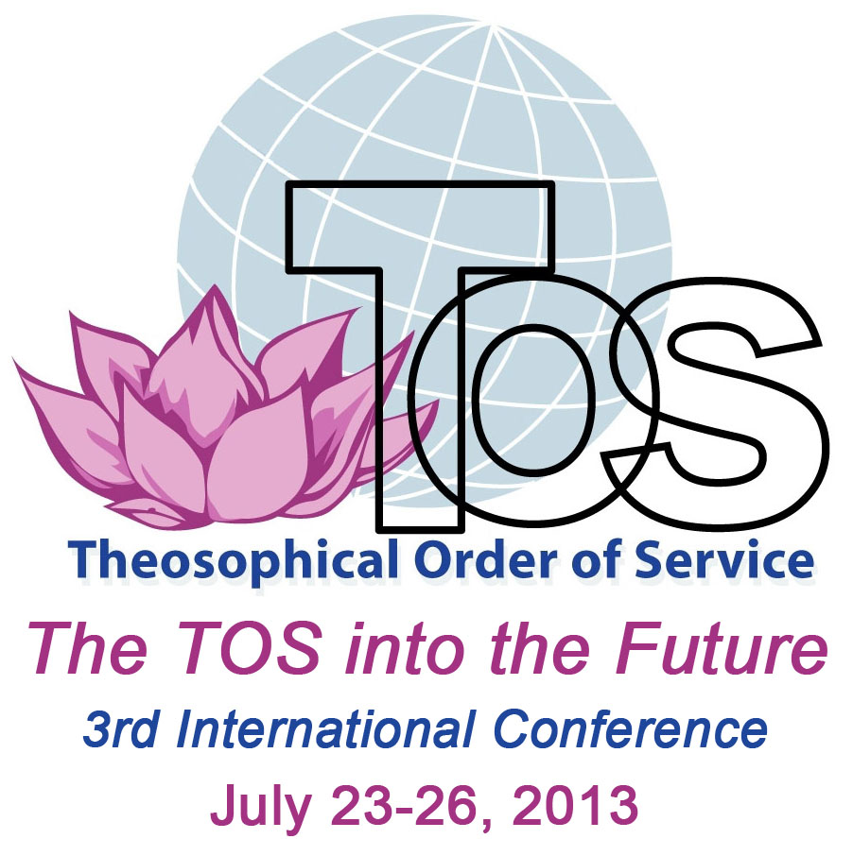

REGISTRATION FEE:
International guests attending any part of the Summer National Convention from 19 July through to 23 July noon: US$30.00 non-refundable registration fee per person, payable on arrival at the Summer National Convention.
International guests are invited to arrive as early as possible on July 19 and to depart on July 27.

ACCOMMODATION PAYMENT: Payable on arrival at the Summer National Convention. Payment in the form of cash or traveller’s cheques in US$ or Visa, MasterCard or Discover credit cards will be accepted. The TSA cannot take American Express.

Holiday Inn - Off Campus (2 miles from Olcott)  150 S. Gary Ave., Carol Stream, IL 60188  Phone: 011-630-665-3000 or 011-800-800-6509  Book your room at E-mail: sales@hicarolstream.com after receiving confirmation of your registration from Registrar.  Special daily rate for those attending both TS & TOS events: US$74.95 plus 11% room tax for single occupancy. $37.50 plus tax per person for twin occupancy. Two-room suite at $99.95 plus tax. (Rooms may be shared by up to 4 people for these prices.)  In-house restaurant available; visit www.hicarolstream.com for menu listing and services.  Free shuttle service available to and from Olcott | Olcott - On Campus (1926 N. Main St., Wheaton, IL 60187)  Very limited, 2 or 3 in a room.  E-mail registrar@theosophical.org about availability.  Cost includes room and meals:  $50 per person / per night; or  $400 for all 8 nights (check in July 19, check out July 27)  Extra nights before & after conferences:  $30 per person per night without meals. Meals may be purchased upon availability: Breakfast $5; Lunch $7; and Dinner $8  Note: During regular business hours, only lunches are prepared Monday-Friday; there are no weekend meals but outside restaurants are nearby.

MEALS: Vegetarian (lacto-ovo) meals are available at Olcott for Holiday Inn commuters: Breakfast: $5; Lunch: $7; Dinner: $8. Individual meals or packages are available, payable at Olcott.
TRANSPORTATION FROM O’HARE and MIDWAY AIRPORTS: We will reserve a limousine for you* but you will be responsible to pay the limo driver (cash, traveler checks, and major credit cards accepted). From O’Hare, $44** including gratuity; from Midway, $48** including gratuity; share ride up to 3 people and group rates also available, to either Olcott or the Holiday Inn (addresses above). You must contact American Limousines 1-888-709-5466 after claiming your luggage and have paper and pen ready to make a note of the limo number as well as where you should meet the limo so that you will be able to identify it when it arrives.
*Send us your arrival/departure dates and flight details as soon as you have them in order to handle limo reservations promptly. **Surcharges may apply if gas prices increase.
- - - - - - - - - - - - - - - - - - - - - - - - - - - - - - - - - - - - - - - - - - - - - - - - - - - - - - - - - - - - - - - - - - - - - - - - - - - - - - - - - - - - - - - - - -
Registration for the 2013 TSA Summer National Convention & TOS International Conference
Date of application:
Name(s):
Full postal address:

Phone: E-mail:

